Создаем бд

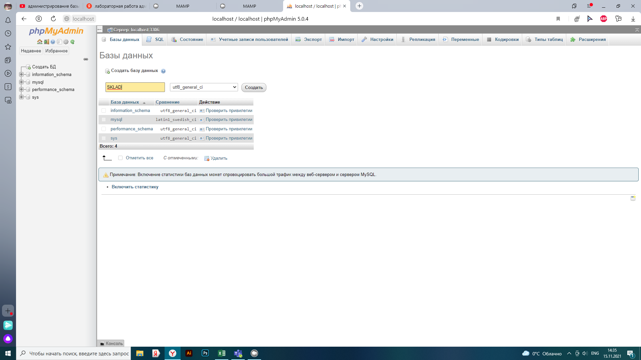

Создаем таблицы

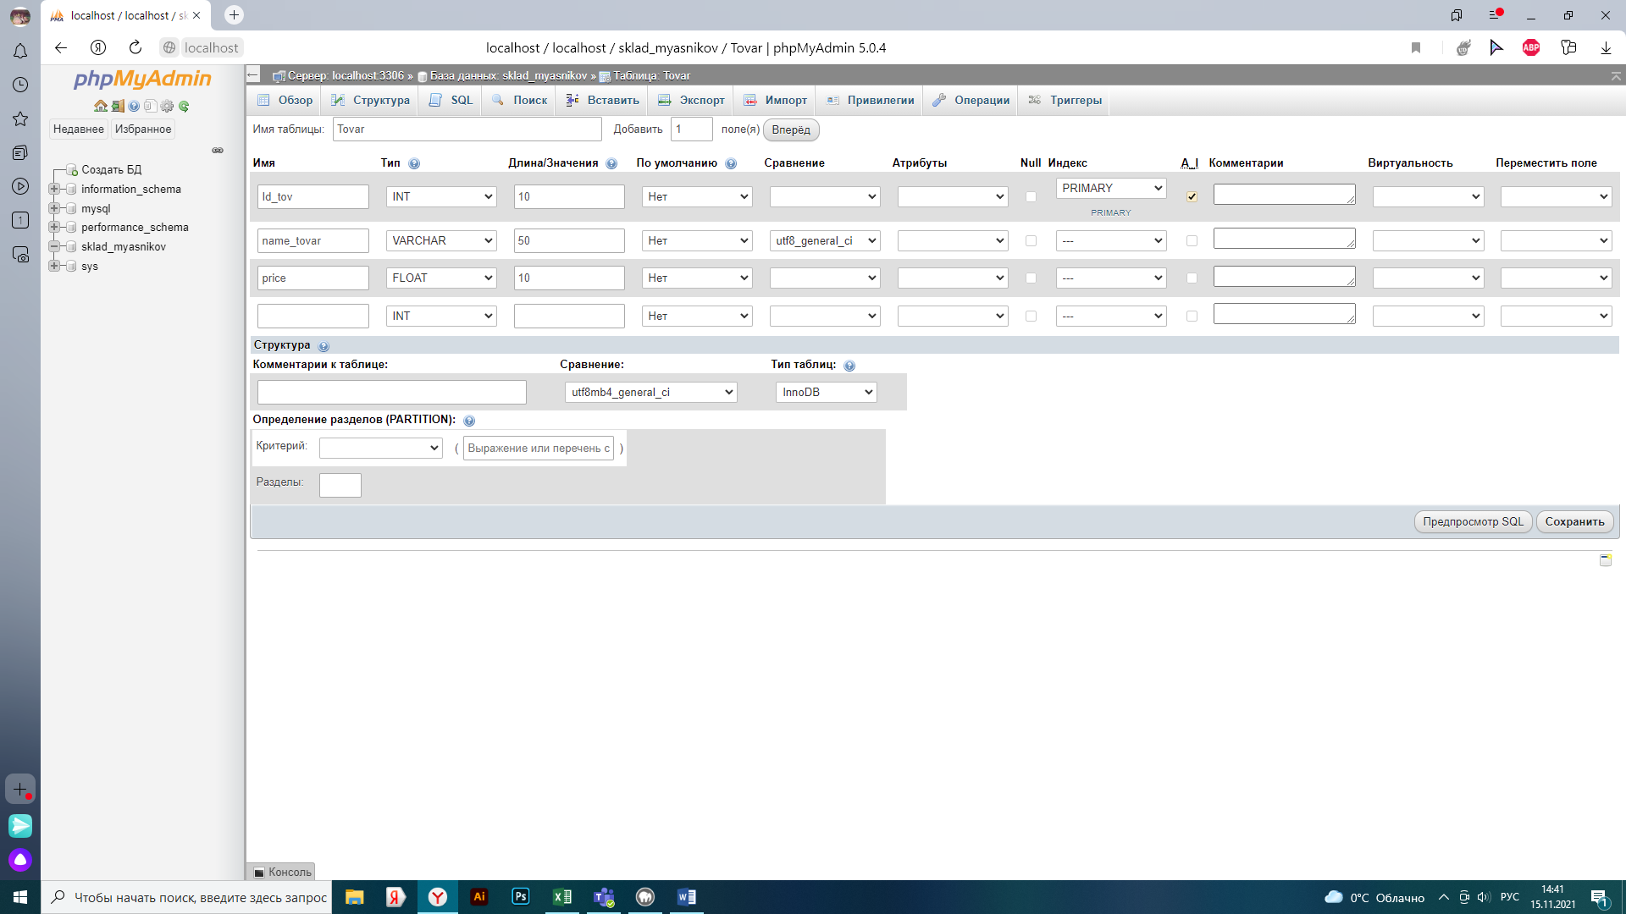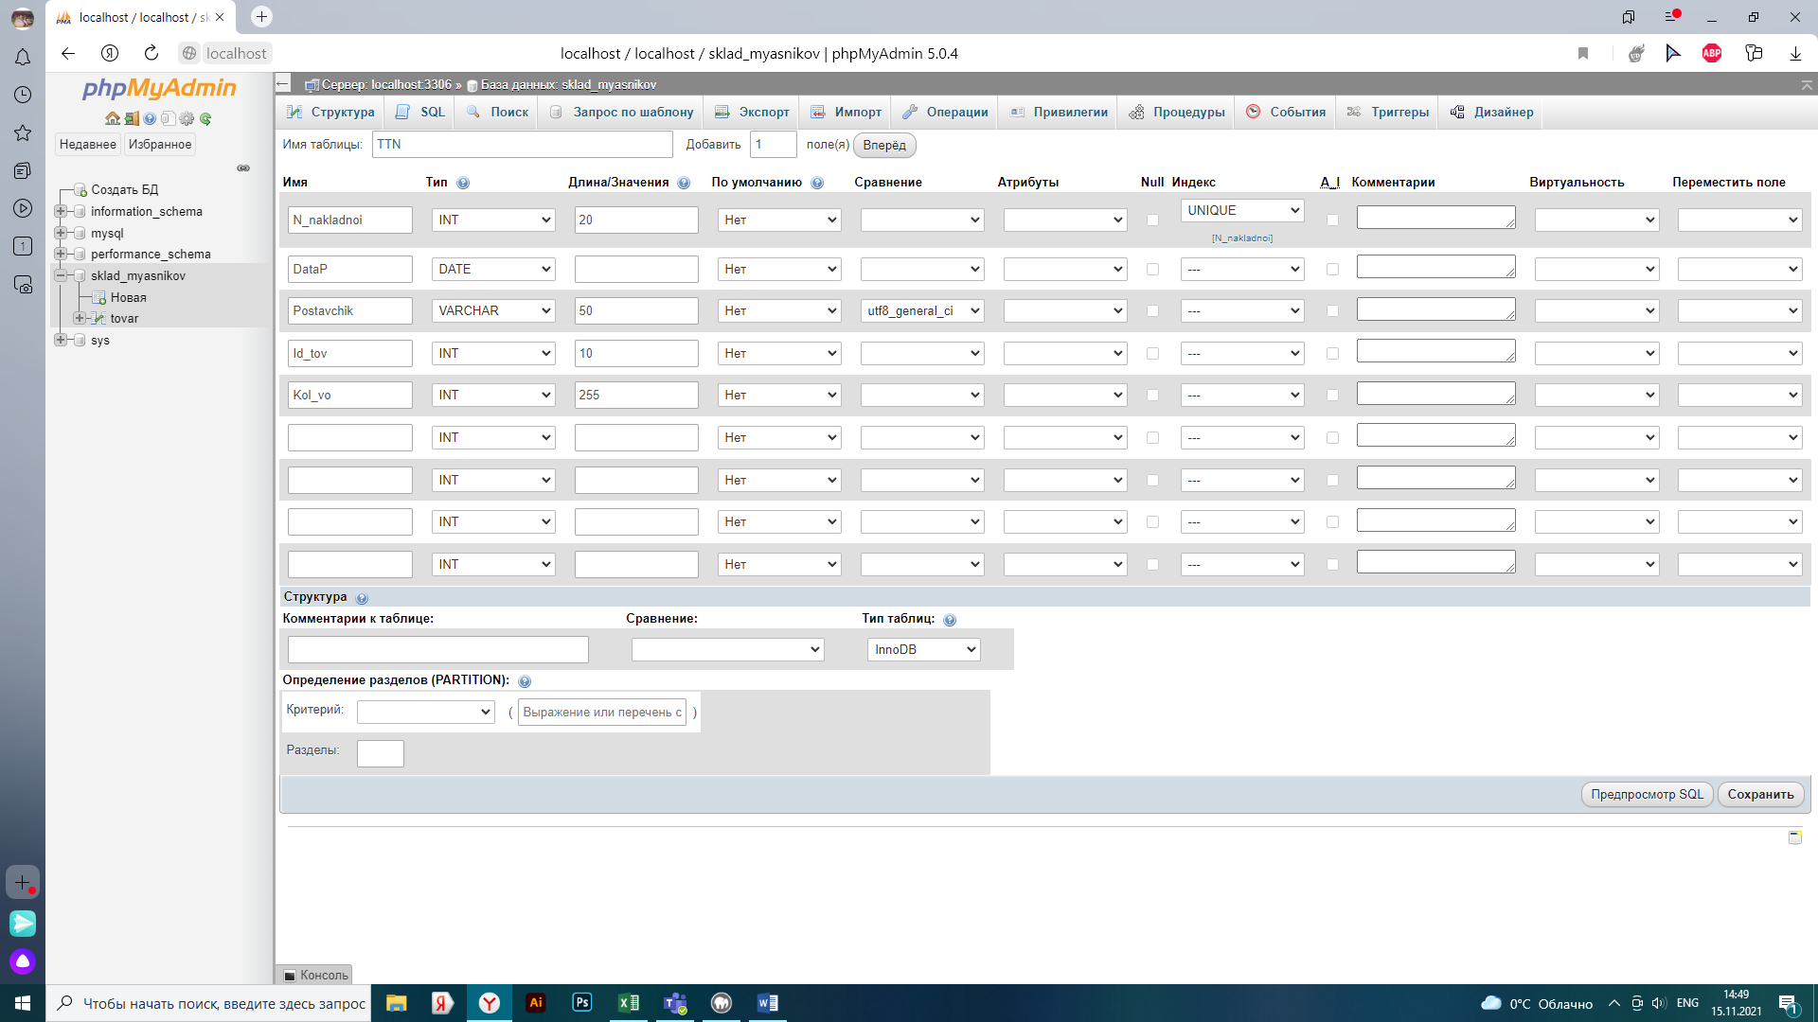

Заполняем таблицы

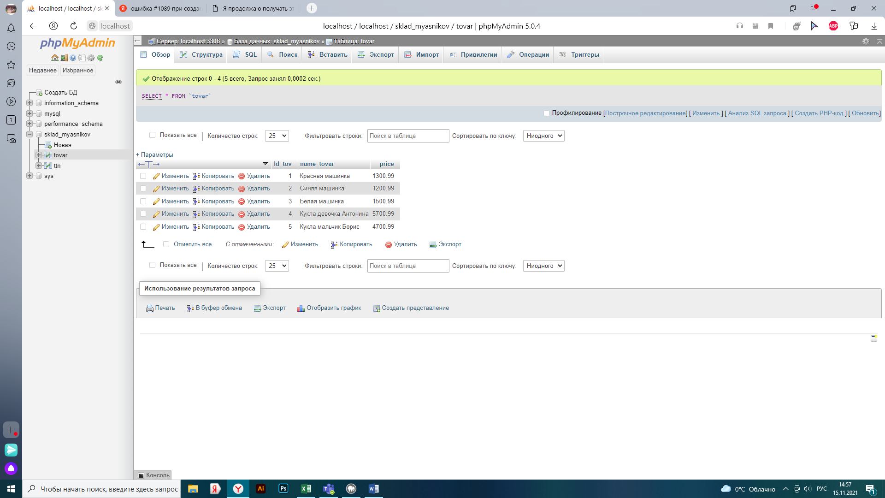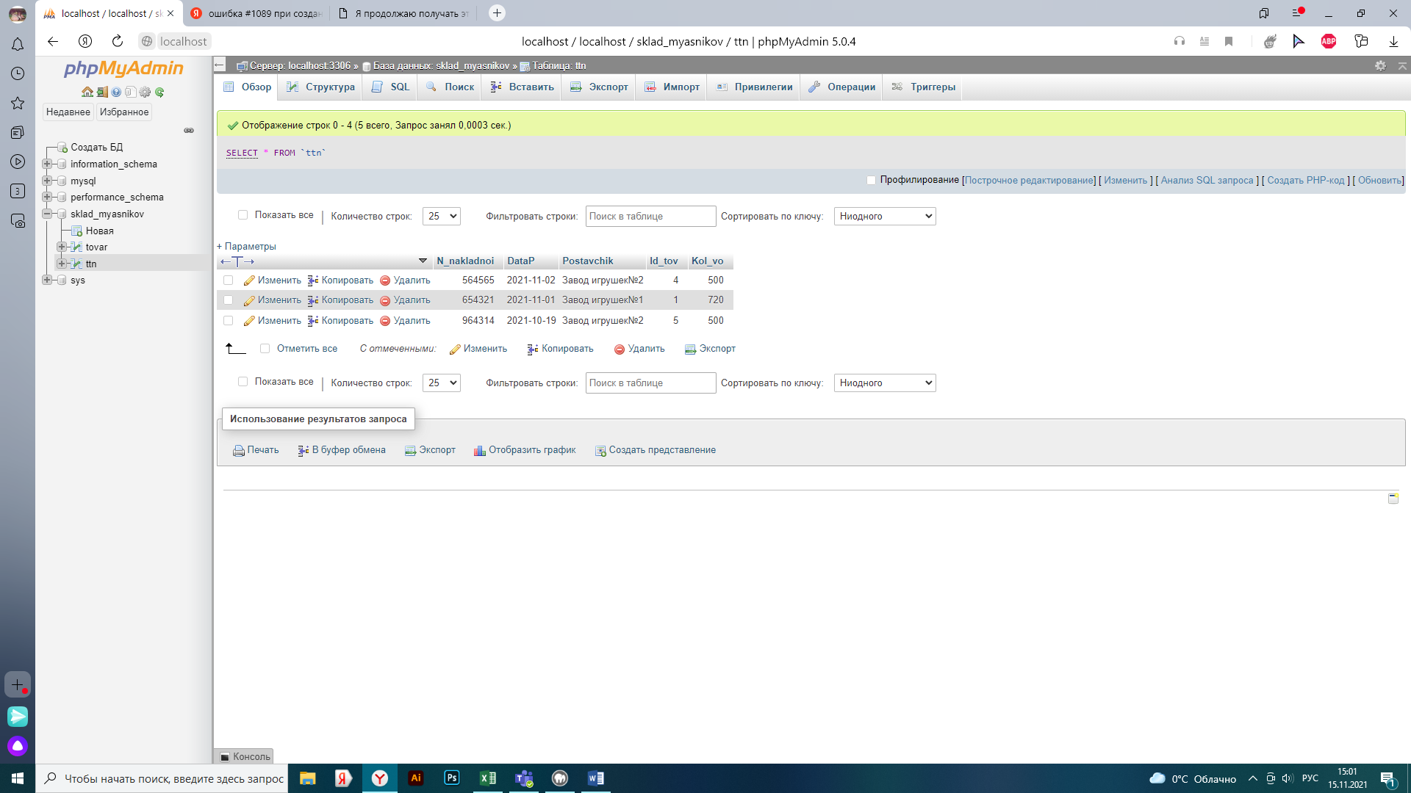

Создаем пользователей и предоставление прав

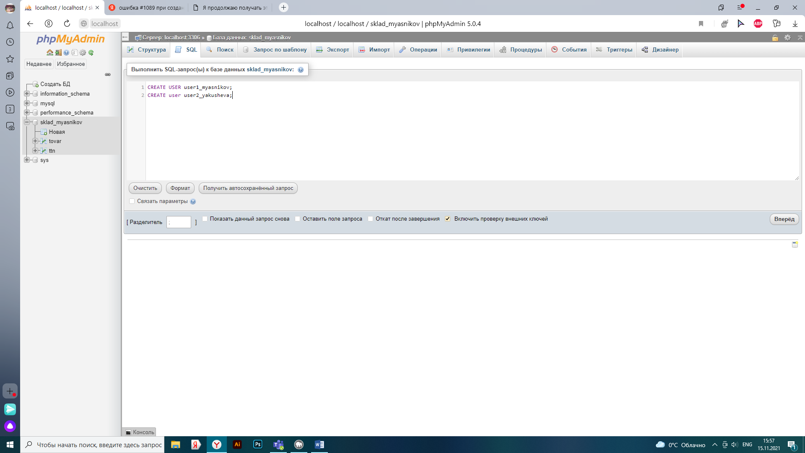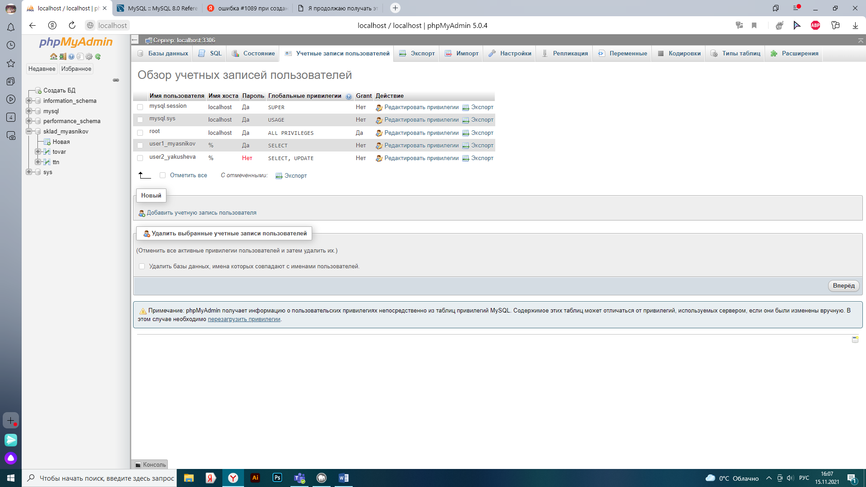

set PASSWORD for user1_myasnikov = PASSWORD('11111');

use sklad_myasnikov;

select * from Tovar;

select * from ttn;

UPDATE `tovar` SET `price` = '4500.99' WHERE `tovar`.`Id_tov` = 5;

INSERT INTO `ttn` (`N_nakladnoi`, `DataP`, `Postavchik`, `Id_tov`, `Kol_vo`) VALUES ('5645616', '2021-11-20', 'Завод игрушек№2', '5', '501');

DELETE FROM `ttn` WHERE `ttn`.`N_nakladnoi` = 654321;

use sklad_myasnikov;

select * from Tovar;

select * from ttn;

[UPDATE](http://localhost/phpMyAdmin/url.php?url=https://dev.mysql.com/doc/refman/5.5/en/update.html) `tovar` [SET](http://localhost/phpMyAdmin/url.php?url=https://dev.mysql.com/doc/refman/5.5/en/set.html) `price` = '4600.99' WHERE `tovar`.`Id_tov` = 5;

[INSERT](http://localhost/phpMyAdmin/url.php?url=https://dev.mysql.com/doc/refman/5.5/en/insert.html) INTO `ttn` (`N_nakladnoi`, `DataP`, `Postavchik`, `Id_tov`, `Kol_vo`) [VALUES](http://localhost/phpMyAdmin/url.php?url=https://dev.mysql.com/doc/refman/5.5/en/miscellaneous-functions.html#function_values) ('546422', '2021-11-01', 'Завод игрушек№2', '5', '800');

DELETE FROM `ttn` WHERE `ttn`.`N_nakladnoi` = 546422;

REVOKE ALL PRIVILEGES ON * FROM 'user1_myasnikov';

REVOKE GRANT OPTION ON * FROM 'user1_myasnikov';

GRANT INSERT, UPDATE ON * FROM TO 'user1_myasnikov';

GRANT SELECT ON sklad_myasnikov.tovar FROM TO 'user1_myasnikov';

REVOKE ALL PRIVILEGES ON * FROM 'user2_yakusheva';

GRANT DELETE ON sklad_myasnikov.ttn FROM TO 'user2_yakusheva';

use sklad_myasnikov;

select * from Tovar;

select * from ttn;

UPDATE `tovar` SET `price` = '3500.99' WHERE `tovar`.`Id_tov` = 5;

INSERT INTO `ttn` (`N_nakladnoi`, `DataP`, `Postavchik`, `Id_tov`, `Kol_vo`) VALUES ('55675616', '2021-01-20', 'Завод игрушек№1', '3', '101');

DELETE FROM `ttn` WHERE `ttn`.`N_nakladnoi` = 178421;

use sklad_myasnikov;

select * from Tovar;

select * from ttn;

[UPDATE](http://localhost/phpMyAdmin/url.php?url=https://dev.mysql.com/doc/refman/5.5/en/update.html) `tovar` [SET](http://localhost/phpMyAdmin/url.php?url=https://dev.mysql.com/doc/refman/5.5/en/set.html) `price` = '4600.99' WHERE `tovar`.`Id_tov` = 5;

[INSERT](http://localhost/phpMyAdmin/url.php?url=https://dev.mysql.com/doc/refman/5.5/en/insert.html) INTO `ttn` (`N_nakladnoi`, `DataP`, `Postavchik`, `Id_tov`, `Kol_vo`) [VALUES](http://localhost/phpMyAdmin/url.php?url=https://dev.mysql.com/doc/refman/5.5/en/miscellaneous-functions.html#function_values) ('54899022', '2021-11-21', 'Завод игрушек№2', '3', '100');

DELETE FROM `ttn` WHERE `ttn`.`N_nakladnoi` = 54899022;